|  |  |
| --- | --- |
| **Mobile Application Development**  Diploma in CSF, FI, DS, IT  AY2022 | Week **3** |
| **2** hours |
| **Exercise 3** | |

Click on this link to join week 3 practical,

<https://classroom.github.com/a/-WI3R7m7>

1. Modify the onClickListener of left button to show a Toast message. The toast message will show Followed if the user click on the Follow button, and vice versa.

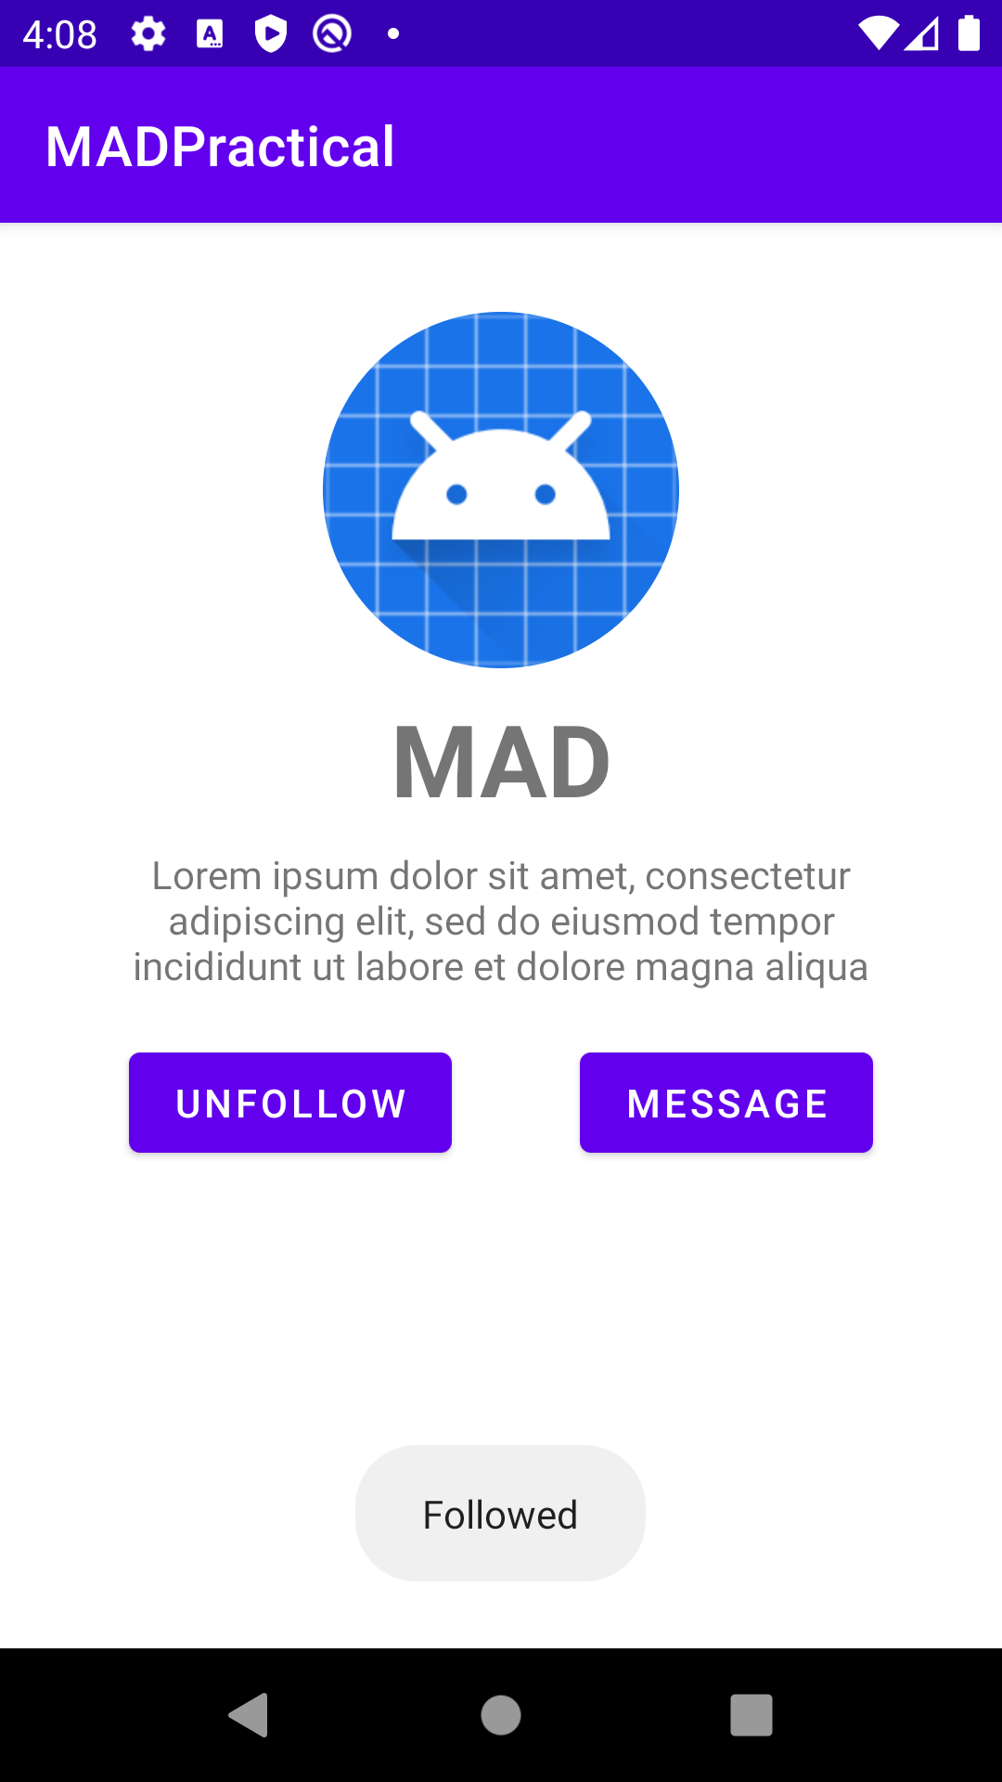

1. Create a new Empty Activity with the following configuration,

Activity Name: ListActivity

Generate a Layout File: Checked

Layout Name: activity_list

Launcher Activity: Checked

Source Language: Java

1. In the activity_list layout file, create an ImageView, position it in the middle of the screen.

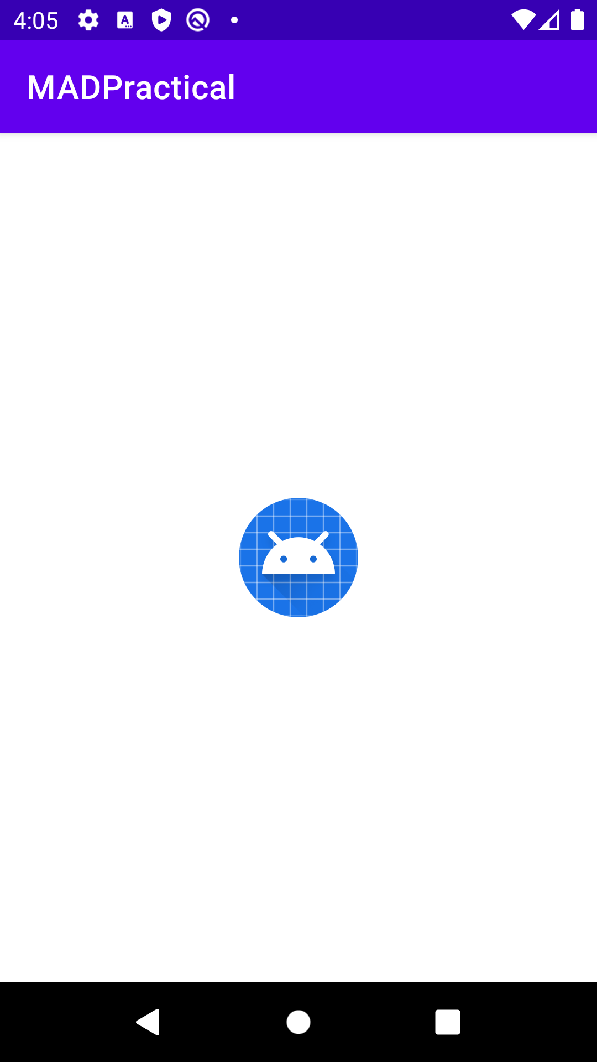

1. Create an onClickListener for the image created in previous step. Upon clicking the image, an AlertDialog will appear as shown in the figure below.

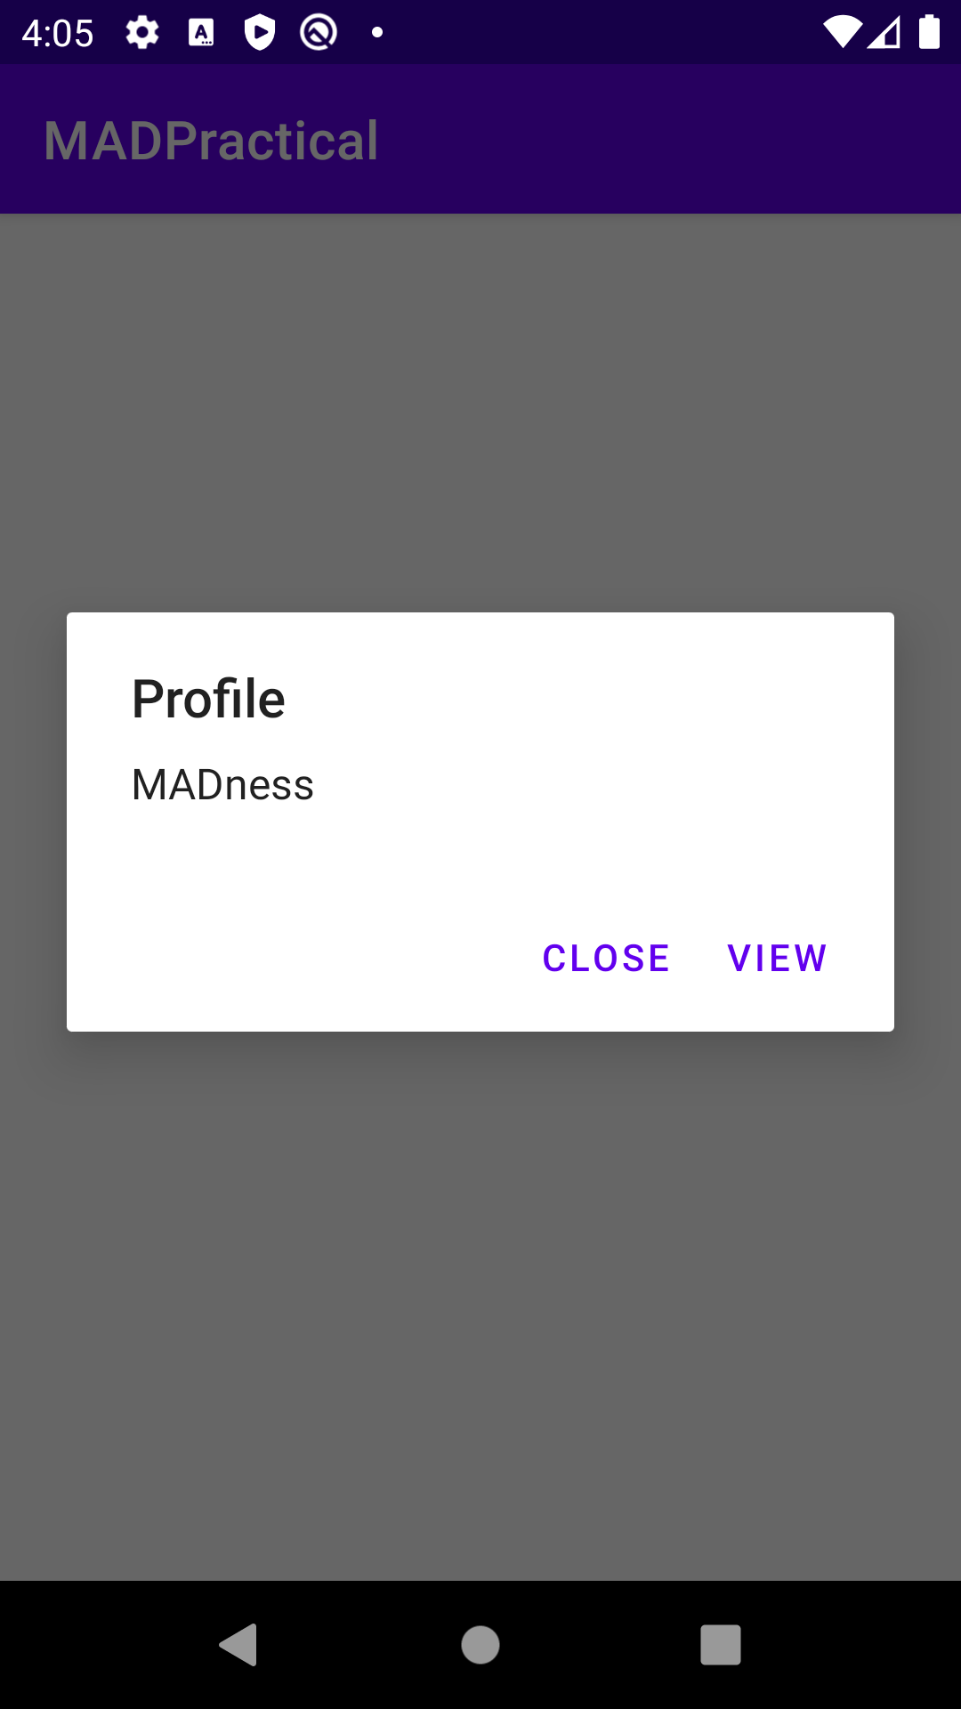

1. Upon clicking the View button, a random integer will be generated. The MainActivity (created in previous practical) will be launched, and the random integer is sent over.

EditText

VideoView

1. Modify the MainActivity to display the random integer together with the name.

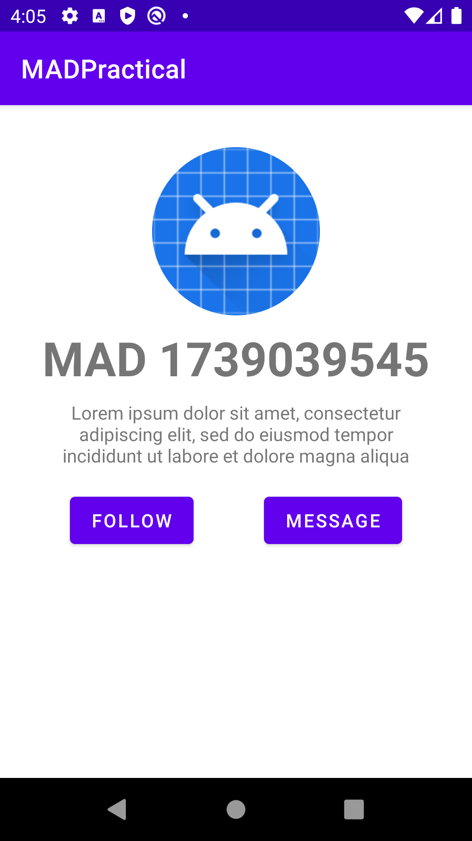

**CHALLENGE**

1. Create a new Empty Activity with the following configuration,

Activity Name: MessageGroup

Generate a Layout File: Checked

Layout Name: activity_message_group

Launcher Activity: Unchecked

Source Language: Java

1. Create an event listener for the Message button. Upon clicking on the button, the Activity created in previous step, MessageGroup, will be launched.

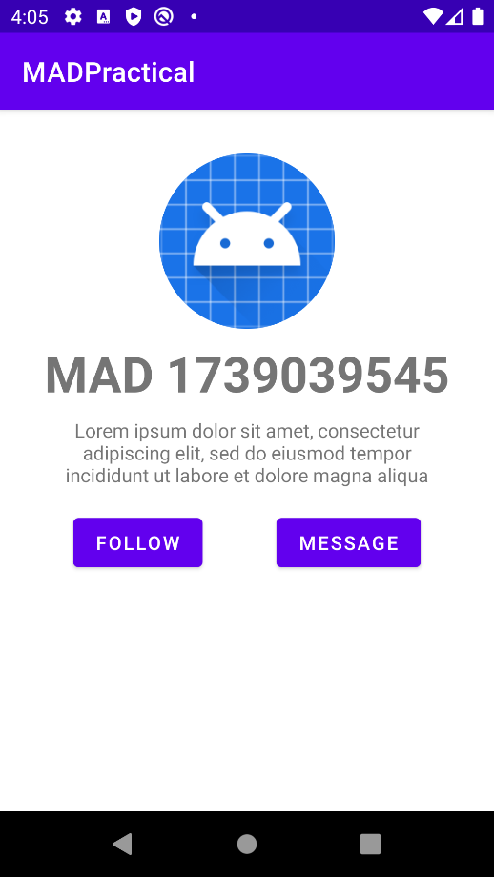

1. Modify the layout of MessageGroup as shown in the image below.

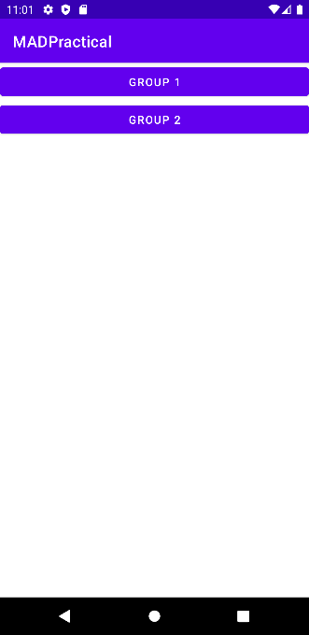

FrameLayout

Buttons

1. Fragments are commonly used in Android applications. They are an extension to Activities. Research and discover how to implement loading of fragment within an activity. Implement MessageGroup as illustrated in the image below.

<https://guides.codepath.com/android/creating-and-using-fragments#embedding-a-fragment-in-an-activity>

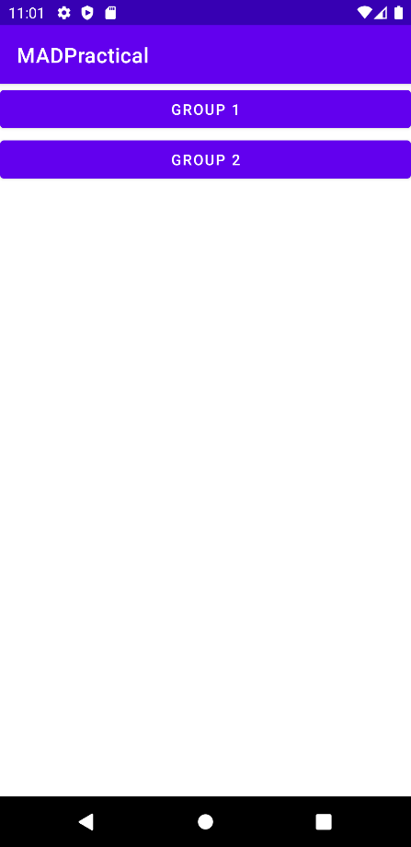

Clicking on Group 2

Clicking on Group 1

